FINSWIMMING

CMAS RULES
VERSION 2015/01
In force as from January 1st 2015

(BoD183 - 03/08/2013)
(Bod184 – 19/10/2013)

CMAS World Underwater Federation

Finswimming Commission

CMAS Finswimming Rules
Version 2015/01

Index

1. Definition................................................................................................................ 2
2. Technical Regulations ............................................................................................... 2
3. CMAS Championship and Competitions ....................................................................... 6
4. Regulations for the swimming-pool set up................................................................. 10
5. Automatic timing and classification equipment........................................................... 11
6. Characteristics of the automatic time-keeping system ................................................ 12
7. Open Water field.................................................................................................... 13
8. Competition Procedure ........................................................................................... 14
9. Board of Judges and Competition Managements ........................................................ 17
10. Finswimming Records ........................................................................................... 20
11. Appendix CMAS Finswimming Rules........................................................................ 23

CMAS Finswimming Rules

Version 2015/01

page 1

CMAS World Underwater Federation

Finswimming Commission

1.DEFINITION
By “finswimming” we mean the progression with a monofin or with two fins either on the surface or
underwater, by means of the swimmers' muscular force only and without use of any mechanism, not even
muscle-powered. For underwater disciplines with breathing equipment, only compressed-air sub-aqua
equipment is allowed.
2.TECHNICAL REGULATIONS
2.1. AGE GROUPS

2.1.1.
2.1.2.
§ Point 1.6.1.3. of CMAS Procedures – Age of Competitors.
The age groups are the following:
a) “SENIOR”


A:
18 years and over

b) “JUNIOR”:


B:
16 - 17 years



C: 14 - 15 years
D: 12 - 13 years


E:
11 years or less (Pre-competition group)

c) “MASTERS”




V0: 29 - 34 years
V1: 35 - 44 years
V2: 45 – 54 years and so on in gaps of 10 years

2.1.3.
Pool competitions can be held over any distance, for individual and relay events, for men
and women.

2.1.3.1.
2.1.3.2.
No competitions are allowed over a distance more than 50 m in apnoea.
Discipline and distance limits for the "junior" groups are:

a) Groups B and C: without limitations.
b) Group D surface and immersion with breathing apparatus, without limitations.
Finswimming in apnoea: maximum 25 m.
c) Pre-competition group: no international competitions; national regulations apply.

2.1.4.
Open water: Competitions can be held over any distance with the condition that full safety

of swimmers is guaranteed.
2.1.4.1. For group D the maximum distance is 6 km.
2.1.4.2. For group C the maximum distance is 8 km.

2.1.5.
It's specified below the minimum age required to participate in the Competitions and

Championships CMAS.




12 years to participate at World Cup
14 years to participate at World, Continental or Zone Junior Championships
15 years to participate at World Cup (to be classified in senior category) and

World, Continental or Zone Senior Championships.
2.2. SWIMMING TECHNIQUE

2.2.1.
Surface finswimming (SF)

2.2.1.1.
2.2.1.2.
The swimming style is unspecified.
Immersion is only permitted over a distance of 15 meters after the start and after

each turn. The snorkel or the head of the swimmer have to go out from the water before
the end of the 15 meters strip.

2.2.1.3.
Outside the 15 meters zone, a part of the swimmer or the equipment must always

emerge from the water surface.

2.2.1.4.
In order to distinguish between surface and apnoea, all swimmers must use a

snorkel for breathing all the time at all the distances

2.2.2.
Apnoea finswimming (AP)

2.2.2.1.
The immersion in apnoea is only permitted in swimming pools (indoor or outdoor).

The judge must be able to follow the movement of the swimmer visually.

2.2.2.2.
2.2.2.3.
2.2.2.4.
The snorkel is not permitted.
The swimming style is unspecified.
While in apnoea the face of the swimmer must be underwater during the whole

distance.

CMAS Finswimming Rules

Version 2015/01

page 2

CMAS World Underwater Federation

Finswimming Commission

2.2.2.5.
2.2.2.6.

If electronic time equipment is used the swimmer must touch the finish touch pad.
If the 50 meters apnoea is swum in a 25 meters pool, the swimmer must touch the

wall with a part of the body or the fin when turning.

2.2.3.
Immersion finswimming with breathing apparatus (IM)

2.2.3.1.
In underwater swimming with compressed air breathing apparatus the swimming

style is unspecified.

2.2.3.2.
2.2.3.3.
The way to carry the equipment used is unspecified.
It is not allowed to change or abandon the breathing apparatus during the

competition.

2.2.3.4.
2.2.3.5.
pads.
2.2.3.6.
The face of the swimmer must be submerged during the whole distance.
If electronic timing equipment is used, the swimmer must touch the finish touch

The breathing equipment must at no time touch the swimming pool walls or the finish

contact pads. Abuse will lead to disqualification.

2.2.4.
Bi-Fins (BF)

2.2.4.1.
2.2.4.2.
The swimming style is crawl swimming on the breast with snorkel.
Dolphin swimming is allowed only during the 15 meters in apnoea after start and

each turn.

2.2.4.3.
Immersion is only permitted over a distance of 15 meters after the start and after

each turn. The snorkel or the head of the swimmer have to go out from the water before
the end of the 15 meters strip.

2.2.4.4.
For the start, the fins of the swimmer must be positioned on a parallel line at the front

of starting block.

2.2.5.
Finswimming in Open Water (OW)

For safety and security reasons, underwater swimming is no permitted in open water
competition. During the race, if a swimmer breaks this rule, the style judge shows him a yellow
card to inform him on his fault. If the style judge notes the fault again, a second yellow card is
shown to the swimmer. With the third fault of underwater swimming, the style judge shows to
the swimmer a red card which informs him on his disqualification.
2.3. EQUIPMENT AND RESTRICTION

2.3.1.
Equipment allowed in pools and in open water for Surface Finswimming (SF), Apnoea

finswimming (AP) and Immersion finswimming (IM) competition:
2.3.1.1. The fin comprises only of a blade and fixed foot pieces.
2.3.1.2. Bi-fins are allowed without any restriction as to the dimensions and the material.
2.3.1.3. Monofin (fig. 1):
a) There is no restriction to the material used.
b) The monofin may float.
c) The maximum size of the monofin is:length 760 mm, width 760 mm,height 150 mm.
d) The width is measured from the left to the right side of the blade.
e) The length is measured between points A and B (see Figure 1).

f)
The height is measured by a temple not exceeding 150 mm.

g) The foot pieces must not be constructed so as to give the swimmer any additional
assistance, and no spring or any device of any kind may be incorporated into the
foot pieces.
h) The foot piece must assure the stability of the swimmer on the starting block.

i)
Screws under the fins and monofin are strictly forbidden except when they are
covered with a thick enough protection.

CMAS Finswimming Rules

Version 2015/01

page 3

CMAS World Underwater Federation

Figure 1

Finswimming Commission

2.3.2.
Equipment allowed in pools and in open water for Bi-Fins (BF) competition:

2.3.2.1. All bi-fins need certification by CMAS. The list and visual are in appendix 11.6
2.3.2.2. Criteria for the certification of bi fins:
a) Available market and big distribution.
b) Maximum sizes:


Fins ( classical model ) Figure 2:

Figure 2


Length : 670 mm
Width : 225 mm


Fins ( diving model ) Figure 3:



Length : 675 mm
Width : 230 mm

Figure 3
c) Materials: Exclusively




Polypropylene ( P.P. )
EVA
All new material to be submitted to approval

d) CMAS logo may be printed on the upper part by the producer in case of certification.
e) Certified fins obligatory for:




The participation at bi fins races in CMAS championships, world cup and in
international competitions.
Certification for any records with bi fins

f)
The code number of the fin must be readable and be checked.

g) Certification to be renewed every two years
h) Certification fee including:



The right to be listed as sponsors in CMAS site
Free advertising banners in CMAS site, zone reserved to Finswimming.

i)

j)
If producer stops the production, fins will be certified until the end of the civil year
following the year of stop.
The price of such certification will be decided by BOD.

CMAS Finswimming Rules

Version 2015/01

page 4
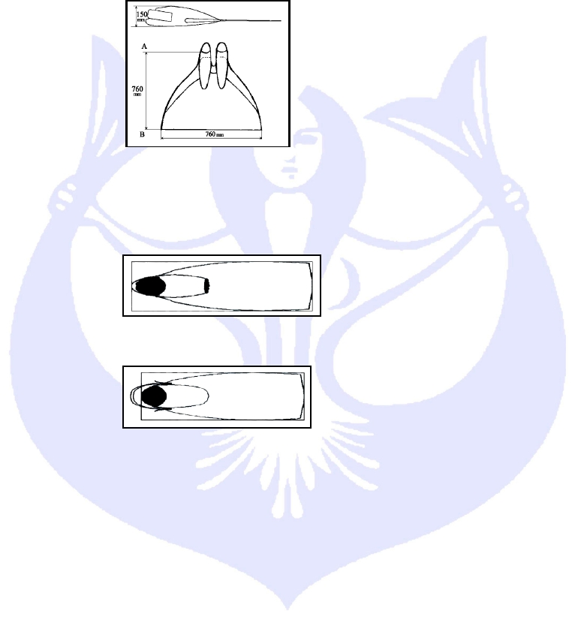

CMAS World Underwater Federation

Finswimming Commission

2.3.2.3. No protuberances or different materials may be applied to fins for altering the efficiency.
2.3.2.4. To fix the bifins to the ankles exclusively three direction (sole, ankle front and back side)
fixing rubber can be used, produced originally by the manufacturer and available market
and big distribution. Neoprene shoes/boots are forbidden whatever the length “a” (Figure
5a). Ends of foot in neoprene or plastic are authorized (Figure 5b).

a

Figure 4

figure5a

Figure 5b

2.3.3.

Other equipment allowed in pools and in open water:

2.3.3.1. Goggles or masks serving only to protect the eyes and improve vision in the water.
2.3.3.2. For Surface Finswimming (SF) and Bi-fins (BF) competition: Snorkels only for breathing
and without fairing (see the picture). Only snorkels with a circular section with a minimum
diameter interior of 15 mm (fifth teen millimetres) and maximum internal diameter of 23 mm
(twenty three millimetres) are permitted. The minimum length of 430 mm (forty three
millimetres) and a maximum overall length of 480mm (four hunderd eighty millimetres) are
permitted. The top end of the snorkel may be cut obliquely or with a round lip but the length
will be measured to the highest point. The lengths of snorkel must be measured inside the
tube.

Figure 6

2.3.3.3.

2.3.3.4.
a)
b)

c)

d)

e)

f)
2.3.3.5.
a)

The goggles, masks and snorkels must not have any attachments serving any
purpose other than the functions listed above.
Immersion finswimming with compressed air-breathing apparatus:
only compressed air without oxygen enrichment is allowed
for pool competitions, the minimum volume of a compressed air cylinder (bottle) is
litres 0.4 (zero point four litre)
The maximum filling pressure for the compressed-air cylinders cannot exceed 200
bar (20 MPa).
when a cylinder with a flat bottom is used, adding a rounded bottom, which does not
exceed the radius of the cylinder, is allowed
All cylinders used must have passed a hydrostatic test less than 2 years before the
competition, or even less if it is required by the local legislation.
Each cylinder must be presented empty during checking meeting before competition.
Auxiliary equipment:
The swimmers must appear in decent sportswear: for men bathing short trunks
(fig.6); for women – normal swimsuits (fig.7) or two pieces normal swimsuit (fig. 8).
Allow using competitive swimsuits (full body or legs (fig.9) and knee suits (fig.10)
only homologated by CMAS and with proper logos. All bathing clothes must not have
an effect on the natural buoyancy of the swimmers. Only one swimsuit is allowed.

CMAS Finswimming Rules

Version 2015/01

page 5
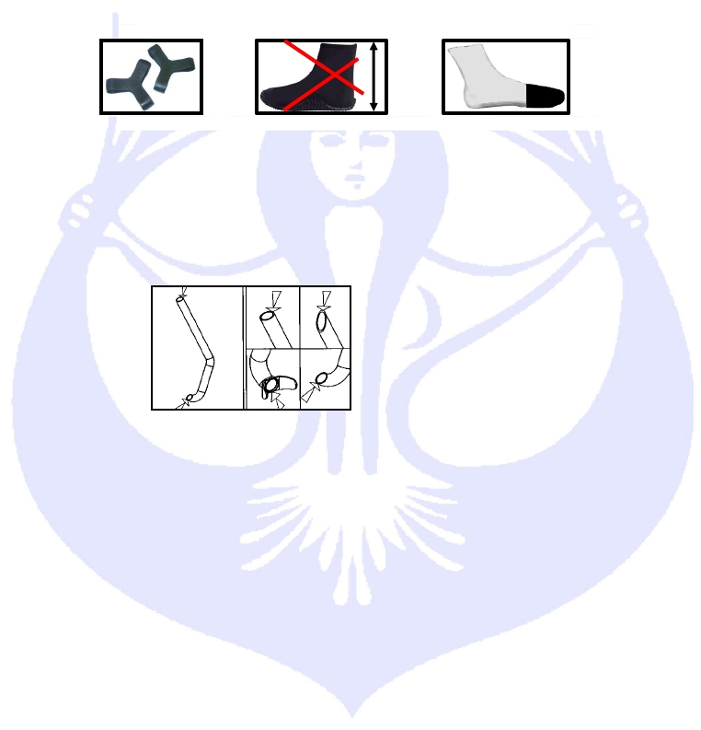

CMAS World Underwater Federation

Finswimming Commission

b) Using neoprene wet suits is authorized only in open water competitions: trousers
and jackets, one-piece or two-pieces. A long gown or skirt (enlarging the surface of
the swimmer) is not allowed. Other auxiliary equipment or buoyancy devices are not
allowed in any case.
c) One or two swim caps are authorized.

2.3.4.

2.3.5.

2.3.6.

2.3.7.
The wearing of advertising slogans on the fins and compressed air tanks during
international competitions and championships is allowed without restrictions. However,
nothing is authorized, as far as the snorkel is concerned, since the latter is an equipment
essential to judging. Advertising slogans are tolerated on the swimmers' sportswear.
However it is stressed that during international championships the swimmers must present
themselves at the different ceremonies (like awards ceremony) in the official dress of their
national team.
The swimmers with not conformed equipment won’t admit to the starting block. If the
irregular equipment is found out after the end of the race, the swimmer will be disqualified.
Any new equipment must be shown for the agreement to the Finswimming Commission
and has to be approved by the BD, before using in competition.
Others auxiliary equipment forbidden

2.3.7.1.
No material except timekeeping system can be positioned on the surface of the

starting block. Nothing can be placed on the surface of the starting block by the swimmers.

2.3.7.2.
Carry a watch or any other similar device is forbidden for the competitions (only in

swimming pool).

2.3.7.3.
Any protection on the inner face of the arms (site located on the position of the head

ring of the snorkel) is regarded as a help and thus prohibited. No exemption from this rule
can be accepted.
3.CMAS CHAMPIONSHIP AND COMPETITIONS
3.1. CLASSIFICATION OF THE COMPETITION

3.1.1.
Two different kind of competition:



Swimming-pool Competition
Open Water Competition

3.1.2.
CMAS Championship and Competition:





World Championship
Continental and zone Championship
World Cup
CMAS Junior Trophy

3.1.3.
CMAS master's competition


World Cup master's

3.1.4.
also:


World Games (organized by IFWGA)

CMAS Finswimming Rules

Version 2015/01

page 6
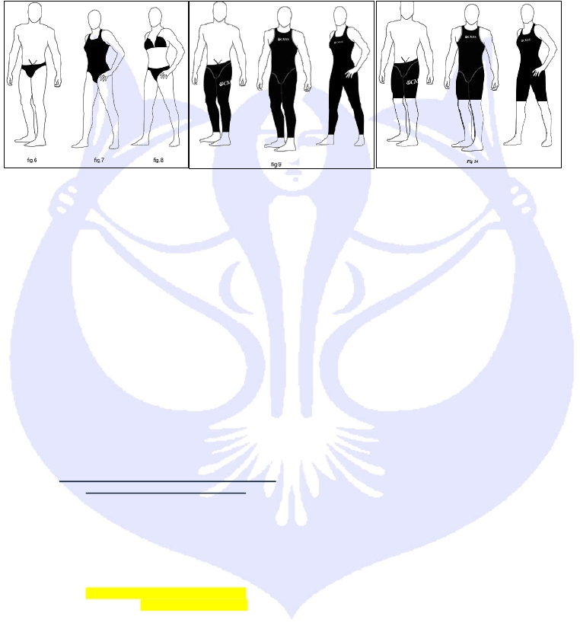

CMAS World Underwater Federation

3.2. WORLD AND CONTINENTAL SWIMMING-POOL CHAMPIONSHIP

Finswimming Commission

3.2.1.
World and Continental Championships are organized every two years alternatively:


World championship:odd years (’07, ’09 , ’11, etc. ) even years (’16, ’18, ’20, etc.)

Note: To change alternation, two successive championships will be scheduled in 2015 and 2016.


Continental championship:even years (’08 , ’10, ’12, etc.), odd years (’17, ’19, etc.)



World junior championship:
Continental junior championship:
even years (’16, ’18, ’20, etc.)
odd years (’15, ’17, ’19, etc.)

3.2.2.

3.2.3.
3.2.4.

3.2.5.

3.2.6.
World and Continental championships must be organized with doping test, according to the
I.O.C. doping regulation and scheduled by Sport Accord .
The championships must be held in officially approved swimming pools
The CMAS Technical Delegate must be nominated by the Finswimming Commission and
approved by CMAS Executive Bureau.
The citizenship of the swimmer is certified by his/her passport. The same holds for the
control of age, in particular for junior swimmers.
In the World and Continental Swimming-pool Championships:

a)

b)

c)

d)

e)

f)
Each country may enter no more than two (2) swimmers for each distance and one
(1) relay team.
A country has the right to change the composition of the relay teams between the
qualifying heats and the final.
The entries must reach CMAS headquarters within the time limits set by the CMAS
rules on www.cmasoffice.org (§ Point 1.21.1.3 &4 of Cmas Procedures)
World and Continental Senior Championships will be organized over five (5) days
and 10 sessions four (4) days and eight (8) sessions.
The qualifying heats are scheduled in the morning and finals in the afternoon except
400 IM, 800 SF and 1500 SF slow heats in the morning and fast heat in the
afternoon. For this reason, it's requested to the national federations to send to the
CMAS HQ the official protocols of all selection national competitions in delay
maximum of two weeks after the competitions (in one of the three CMAS
languages). Thus, times of enrollments of the swimmers will be checked for CMAS
championships. If the protocols aren't transmitted in this deadline, times of
corresponding enrollments will be cancelled and the athletes will be engaged with
time 00:00:00.
The 4-day program:

Morning HEATS or SLOW HEATS
100 SF Women
100 SF Men
100 BF Women
100 BF Men
400 SF Women
400 SF Men

100 IM Women
100 IM Men
1500 SF Women (slow heats)
1500 SF Men (slow heats)
200 BF Women
200 BF Men
200 SF Women
200 SF Men

CMAS Finswimming Rules
Afternoon FINAL or FAST HEAT
100 SF Women
100 SF Men
100 BF Women
100 BF Men
400 SF Women
400 SF Men

100 IM Women
100 IM Men
1500 SF Women (fast heat)
1500 SF Men (fast heat)
200 BF Women
200 BF Men
200 SF Women
200 SF Men

Version 2015/01
Medal Ceremony

100 SF Women
100 SF Men
100 BF Women
100 BF Men
400 SF Women
400 SF Men

100 IM Women
100 IM Men
1500 SF Women
1500 SF Men
200 BF Women
200 BF Men
200 SF Women
200 SF Men

page 7

Day 2
Day 1

CMAS World Underwater Federation

50 SF Women

50 SF Women

Finswimming Commission

50 SF Men
50 BF Women
50 BF Men
400 IM Women (slow heats)
400 IM Men (slow heats)
4x200 SF Women
4x200 SF Men

50 AP Women
50 AP Men
800 SF Women (slow heats)
800 SF Men (slow heats)
4x100 SF Women
4x100 SF Men
50 SF Men
50 BF Women
50 BF Men
400 IM Women (fast heat)
400 IM Men (fast heat)
4x200 SF Women
4x200 SF Men

50 AP Women
50 AP Men
800 SF Women (Fast heat)
800 SF Men (Fast heat)
4x100 SF Women
4x100 SF Men
50 SF Women
50 SF Men
50 BF Women
50 BF Men
400 IM Women
400 IM Men
4x200 SF Women
4x200 SF Men

50 AP Women
50 AP Men
800 SF Women
800 SF Men
4x100 SF Women

4x100 SF Men

Note: point of version 2013-01 deleted are
3.2.6. g) – h) concerning three days program.

3.3. WORLD AND CONTINENTAL OPEN WATER CHAMPIONSHIP

3.3.1.
The World and Continental Open Water Championships are held over one day with the
following program:



Morning: relay 4x2 km
Afternoon: 6 km individual.

3.3.2.

3.3.3.
Each country may enter not more than four (4) swimmers for each distance and one (1)
relay team.
The relay team is mixed. It's necessarily composed of two female athletes and two male

athletes. The starting order is free and is decided by the team leader according point 8.2.4
below.
3.4. PROGRAMME OF THE WORLD CHAMPIONSHIP

3.4.1.

3.4.2.
The programme of the World Championship, senior and junior, will include the swimming-
pool and the Open Water schedule.
The programme of the Continental Championship, senior and junior, can include the

swimming-pool and the Open Water schedule.
3.5. WORLD CUP SWIMMING-POOL AND WORLD CUP OPEN WATER

3.5.1.
See the “Appendix CMAS FS Rules” enclosed.

3.5.1.1. CMAS World Cup is organized every year.
3.5.1.2. The clubs need to send agreement from their national federation.
3.5.1.3. World Cup must be organized with doping test, according to the I.O.C. doping
regulation and scheduled by Sport Accord .
3.5.1.4. There are two different category in the World Cup competition:
a) Category “Senior”;
b) Category “Junior”;
3.5.1.5. There will be classification for Individuals and Clubs.
3.6. CMAS JUNIOR TROPHY

3.6.1.
3.6.2.
CMAS Junior Trophy is organized every years and reserved to junior national teams.
This championship must be organized with doping test, according to the I.O.C. doping

regulation and scheduled by Sport Accord .

3.6.3.
In the CMAS Junior Trophy:

a)
Each country may enter no more than two (2) swimmers for each distance and one
(1) relay team.

CMAS Finswimming Rules

Version 2015/01

page 8
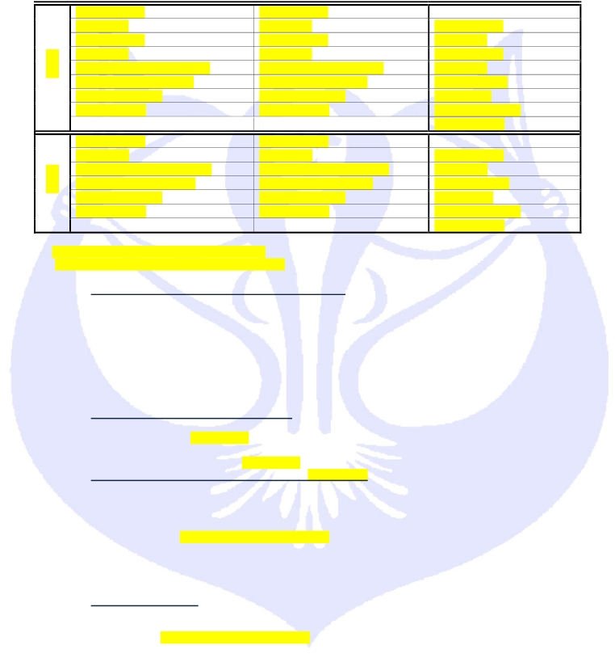

Day 4
Day 3

CMAS World Underwater Federation

Finswimming Commission

b)

c)

d)
e)

f)

A country has the right to change the composition of the relay teams between the
qualifying heats and the final.
The entries must reach CMAS headquarters within the time limits set by the
particular rules of the Trophy.
There will be classification for Individuals and Clubs.
Programme:

For every race of the program, the classification will be according the following

CMAS Swimming-Pool Individual Point Table:

3.7. CMAS MASTER'S WORLD CUP

3.7.1.
3.7.2.
See the “Appendix CMAS Master's world Cup Rules” enclosed.
The CMAS General Rules and CMAS Finswimming Rules will be applied, except point

2.3.3.5 & 4.7 of CMAS Finswimming Rules. The CMAS Master’s World Cup can be held in 25
m Swimming Pool with the width minimum of 12m (6 lanes). No records are homologating in
Master’s ages groups.

3.7.3.
World Cup must be organized with doping test, according to the I.O.C. doping regulation

and scheduled by Sport Accord .
3.8. WORLD GAMES (ORGANIZED BY I.W.G.A.)

3.8.1.
The participation in the World Games is reserved to the best swimmers and best relay

teams selected by CMAS.

3.8.2.
The best eight (8) swimmers of the CMAS World Ranking will participate to the World

Games.

3.8.3.
The complete list of the participant swimmers will be decided by the CMAS Finswimming

Commission after the agreements of CMAS BOD.

3.8.4.
The national federation must confirm the participation of the swimmers selected before the

deadline fixed by the CMAS in agreement with the organizer. Past the deadline, if available
places do exist, the invitation will be extended, in decreasing order, to the swimmers following
in the World Ranking up to the limit of availability.

3.8.5.
Each country may enter not more than two (2) swimmers for each distance and one (1)

relay team, according to the qualification. A place for the relay is reserved obligatory for the
teams of the organizing country.

3.8.6.
The program of the World Games, over two days, include the following races for women

and men:


50 m AP, 100 m SF, 200 m SF, 400 m SF, 4 x 100 m SF.

CMAS Finswimming Rules

Version 2015/01

page 9
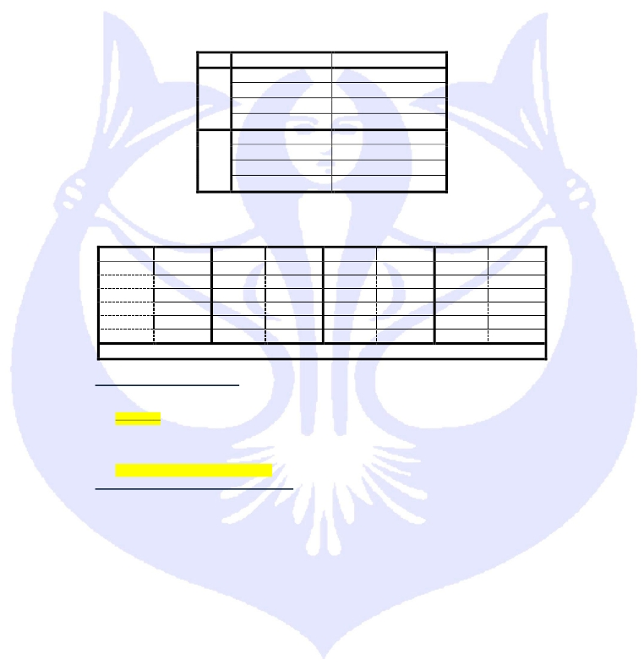

Place points |  | place points |  |  |  | place points |  |  |  | place points
st  1 50  nd  2 46  rd  3 42  th  4 39  th  5 36  th  6 33 |  | th  7 30  th  8 27  th  9 24  th  10 22  th  11 20  th  12 18 |  |  |  | th  13 16  th  14 14  th  15 12  th  16 10  th  17 8  th  18 7 |  |  |  | th  19 6  th  20 5  st  21 4  nd  22 3  rd  23 2  th  24 1
All other swimmers who finish the race will receive 1 point for a successful participation.
Day | Morning | Afternoon
 | 50 SF | 100 BF
 | 50 BF | 1500 SF Men
 | 400 SF | 4x 200 SF
 | 100 SF
 | 200 SF | 50 AP
 | 200 BF | 800 SF Women
 | 100 IM | 4x100 SF
Day 2
Day 1

CMAS World Underwater Federation

Finswimming Commission

3.8.7.

For all the distance: qualifying heats and final.

3.9. CMAS WORLD RANKING

3.9.1.
The results (time) of the swimmers who participate in the CMAS Finswimming

Championship and CMAS Finswimming World Cup rounds will create the CMAS World
Ranking.

3.9.2.
The World Ranking will be prepared for the categories Senior and Junior.

4.REGULATIONS FOR THE SWIMMING-POOL SET UP
4.1. For CMAS championships, the pool must satisfy the following conditions:




length: 50 meters
width: minimum 21 meters
depth: minimum 1,80 meters

4.2. When electronic pads are installed at the start end of the pool and at the end of the turn, the pool
length between the two pads must be no shorter than 50 meters.
4.3. In relation to the nominal length of 50 meters, a tolerance of plus 0,03 and minus 0,00 meters on
the two end walls is permitted, measured from 0,3 meters above to 0,8 meters below the water
surface. An engineer or another official appointed or approved by the federation of the hosting
country will certify these measurements.
The tolerances cannot be violated when the electronic pads are installed.
4.4. The end walls must be parallel forming right angles with the swimming trajectory and the water
surface. They will be constructed from a solid material with a non-skid surface that extends to 0,80
meters under the water surface, permitting to the swimmers to touch it and push it without danger.
4.5. Resting boards projecting on the pool walls are allowed. They must be situated at a minimum of
1,20 meters below the surface of the water and may have a width of 10 to 15 centimetres.
4.6. Overflows can be placed on the four walls of the pool. If the overflows are placed on the end walls,
they must allow the electronic pads to be fixed at the required height of 0,3 meters above the water
surface. They must be covered by a grate or by an adequate screen. Adjustable closing valves
must equip all overflows, so that the water is maintained at a constant level.
4.7. The lanes must have a width of at least 2,5 meters with at least 2 spaces of 0,2 meters on the
outside of the first and last lane. There must be a minimum of 8 lanes.
4.8. Lane markers must cover the whole length of the lane and be fixed by hooks embedded on the end
walls. Each lane marker must be made of buoys placed from one end to the other, with a minimum
diameter of 0,05 meters and a maximum of 0,15 meters. More than one lane marker between each
lane is not permitted. The lane markers must be stretched tight.
4.9. Starting blocks must be firmly fixed with no springboard effect. The height of the starting block over
water surface must be from 0,5 to 0,75 meters. The surface must be at least of 0,5 per 0,5 meters
and covered by a non-skid material. The maximum slope should not exceed 10°. Starting blocks
must be installed on the two ends of the pool.
4.10. Each starting block must be numbered on all four sides, in a clear, visible, way. Lane number 1
must be on the right-hand-side when facing the pool from the starting end.
4.11. Water temperature must be between 25 Celsius and 28 Celsius during the competition, the water
of the pool must be kept at a constant level, without observable currents. To observe hygiene
regulations in force in most countries, the water circulation is authorized provided there is no
formation of current or waves.
4.12. The marking of the lanes must be of a dark colour with contrast to the pool sides. The marking
lines on the bottom of the pool at the centre of the lanes must be: width minimum 0,2 meters,
maximum 0,3 meters for a length of 46 meters for pools of 50 meters length. Each lane marking
line must end at 2,0 meters from the pool’s end walls with a distinct perpendicular line of 1 meter
length and of the same width as lane lines. The finishing lines must be placed on the end walls or
on the electronic pads, at the lane centre, and of the same width of the lane lines. They must
extend with no interruption from the edge of the pool to the bottom. A perpendicular line of 0,5
meters must be placed at 0,3 meters under the surface of the water, measured from the centre of
the perpendicular line.
4.13. The 15 meters areas are marked with a 20 centimetres wide strip that must be fixed on the floor
of the swimming pool, 15 meters away from each end of the start and turning wall; as well as a
mark in the same position, one meter above the water surface.

CMAS Finswimming Rules

Version 2015/01

page 10

CMAS World Underwater Federation

Finswimming Commission

4.14. At all international competitions, no smoking shall be permitted in any area designated for
swimmers, either prior to or during competitions.
5.AUTOMATIC TIMING AND CLASSIFICATION EQUIPMENT
5.1. An automatic or semiautomatic timing and classification system records the race time of each
swimmer and determines his/her place. The classification and the timing must be made with a
precision of two digits after the point (1/100 of a second). The place and the resultant times prevail
upon the decisions of the time-keepers. The equipment installed must not hinder the starts, the
turns of the swimmers or the functioning of the overflow system.
5.2. When timing to 1/1000 is used the third digit shall not be recorded and not used to determine the
places. In the event of equal times, all swimmers who have recorded the same time at 1/100
second shall obtain the same place. When an electronic spectator score board is used, time should
be shown only to 1/100 of a second.
5.3. Any time measurement made by the time-keepers is considered as manual time. Three official
time-keepers per lane must ensure the manual timing. All timing must be certified as exact and
approved by the chief judge. A manual timing must be recorded at 1/100 seconds. If no automatic
equipment is used, the official manual timing must be determined as follows:






If two (2) of the three chronometers show the same time and the third shows a
different time, the two timers recording the same time, will be official.
If three (3) chronometers show different times, the chronometer showing the
intermediate time will be official.
If the time is registered only by two time-keepers, the official time is the larger of

the two.
5.4. If the automatic equipment is not functioning properly and does not record the placing or the time of
one or more swimmers in a heat, it is necessary to record all the times and placing taken by the
equipment and record all the times and placing determined by the judges.
5.5. In order to determine the official placing in a heat, the time given by the automatic equipment will
be considered official. If the equipment is defective, the swimmers' official times will be determined
by a manual timing. In this case, the protocol must note 'manual'.
5.6. The relative order of all the swimmers whose placing has been determined by the equipment will
remain unchanged. If the equipment gives the time of a swimmer but fails to give his relative
placing, the latter will be determined by comparing the swimmer's time with the other swimmers'
times taken by the equipment. If the equipment does not give the time and the placing, this will be
determined by the decision of the judges.
5.7. In order to determine the relative order of arrival of all the heats of a competition, the relative order
of the times taken by the equipment will be used. If more than one swimmers finish equally placed
according to the official times taken by the equipment, they will be equally placed in the order of
arrival of that competition. The placing of a swimmer, whose time is manually taken, will be
determined by comparison of his time with the manual time of all swimmers in that competition. If
more than one swimmers finish equally placed according to their manual official times, they will be
equally placed in the relative order of arrival of that competition. The relative placing of their heats
will be respected.
5.8. Time-keeping with electronic starting blocks: Before each competition tests are performed in order
to determine the time at relay changes (10/100 second). After the relays the Chief Judge will
examine the validity of the relay changes according to this protocol.
5.9. The hierarchy between time-keeping systems and classification is as such:
a) electronic time-keeping system with touch-pads (fully-automatic)
b) electronic time-keeping system judge-operated (semi-automatic)
c) digital watches (provided that there are three of them per lane)
d) classification by finishing-judges

5.9.2.
The results of the automatic electronic time-keeping have absolute priority. If the electronic

time-keeping does not function in automatic mode, the semi-automatically obtained results are
retained.

CMAS Finswimming Rules

Version 2015/01

page 11

CMAS World Underwater Federation

Finswimming Commission

5.9.3.

If there is no electronic time-keeping the results of times registered by the time-keepers are

used for the classification (rather than the order given by the finishing judges) provided three
digital stopwatches are used per lane.

5.9.4.
If there are fewer than three digital stopwatches per lane, the decision of the finishing

judges determines the classification. In this case, and if the time measured by the time-keepers
does not correspond to the decision of the finishing judges and the time of the second
swimmer is better than the time of the first, the arithmetic mean of the two times is attributed to
both swimmers.
6.CHARACTERISTICS OF THE AUTOMATIC TIME-KEEPING SYSTEM
6.1. THE EQUIPMENT MUST COMPLY WITH THE FOLLOWING RULES:
a) It must be started by the starter.
b) No wires must be seen on the poolside, if possible.
c) It must allow the visualization of information for each swimming lane, ordered by lane
and place.
d) It must allow an easy reading of the swimmers' times.
6.2. EQUIPMENT FOR THE DEPARTURE
a) The starter must have at his disposal a microphone for verbal orders.
b) If an air-gun is used for the start, it must have a transducer.
c) Both the microphone and the transducer must be connected to a loud speaker to each
starting block, making possible for each swimmer to hear equally and simultaneously
the orders and the starting signal given by the starter.
6.3. THE ELECTRONIC PAD FOR THE AUTOMATIC EQUIPMENT.
a) The minimum dimensions of the electronic pads must be 2,4 meters of width and 0,9
meters of high, and their maximum thickness must be not more than 0,01 meters. They
must extend 0,3 meters above and 0,6 meters below the surface of the water. The
equipment in each lane must be independently connected, permitting an individual
control. The pad surface must be coloured and must bear the markings of the
extremity walls.
b) The finish pad should be installed in fixed position in the centre of the lane. The pads
may be portable allowing the pool operator to remove them when there is no
competition.
c) The sensitivity of the pad should be such that it can be activated by a light hand touch
but not by water turbulence. The pads must be sensitive at the upper edge.
d) The marking on the pads should conform and fit with the existing marking of the pool.
A black border of 0,025 meters should exist and mark the pads perimeter and edges.
e) The pad should preclude the possibility of electrical shocks and should have no sharp
edges.
6.4. With semi-automatic equipment, the finish should be recorded by push buttons activated by the
time-keepers at the finishing touch of the swimmer.
6.5. The following accessories are obligatory for a minimum installation of automatic equipment:
a) printout of all information that can be reproduced during a run
b) spectator score board
c) estimation of the relay to 1/100 seconds (electronic starting blocks being present)
d) automatic lap counter
e) readout of splits (intermediate times)

f)
computer summaries

g) correction of incorrect touch
h) automatic rechargeable battery operation possibility
6.6. There must be a control centre, with a wide open view on the finishing wall during all the
competitions. The chief judge must have easy access to this control centre. At all times, the safety
of the control centre must be maintained.

CMAS Finswimming Rules

Version 2015/01

page 12
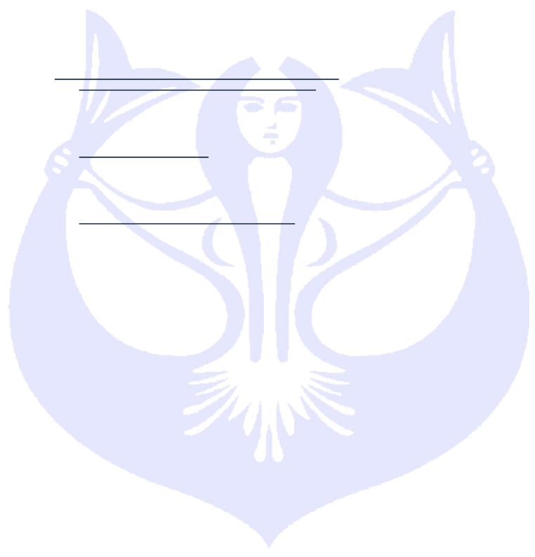

CMAS World Underwater Federation

Finswimming Commission

7.OPEN WATER FIELD
7.1. Finswimming in open water must be defined as any competition that takes place in rivers, lakes or
sea.
7.2. The distance must be chosen in waters with low currents and tides. The water can be either fresh
or salty.
7.3. During the competition need security boats, not less than one (1) boat every ten (10) swimmers.
7.4. The water temperature will be of 14 Celsius minimum to swim without neoprene swimming suit. It
will be verified the day of the competition, two hours before the start, in the middle of the distance
at a depth of 0,40 meters. If the temperature is lower than 14 Celsius, swimmers are obliged to
wear a neoprene swimming suit during the competition.
7.5. A certificate from the local competent authorities for hygiene and safety must ascertain that the site
is appropriate for swimming.
7.6. Every turn and change of directions must be clearly signalled by a visible buoy. In the CMAS
Championship, a floatable rope or a lane longer than 15 meter must join at every “turn buoy” fixed
in the same direction of the next buoy.
7.7. From every buoy not more than 500 meters.
7.8. A boat or a platform clearly signalled with, on board, minimum a turn judge, must be placed at each
turn of the run without disturbing the view of the swimmer.
7.9. All equipment for the turns and every boat or platform of the turn judges, must have a solid
anchorage and must not be subject to the movement of tides, wind etc.
7.10. The arrival is signalled by a finishing cone like following explanation map:

7.11. The relay area comprises the finishing cone and a special 10 meters marked zone at the exit of
the cone where swimmers will wait for their arriving team mates.
7.12. After leaving the arrival cone, the swimmers will pass the relay by a physical contact.
7.13. When they approach the finishing-line, swimmers must enter the arrival cone and complete their
course inside the cone, or else be disqualified.
7.14. For competitions of length over 12 km and if the circuit comprises several laps, the race is over in
the same lap as the winner. This means that when the first swimmer crosses the finishing line all
other swimmers end their race when they cross the line even if they are at one of several laps
behind the winner. (The judges must indicate the end of the race in a clear way, explained in
advance). If the competition is on a straight line the organizer indicates the end of the race by
reference to the time of the winner. A typical choice is between 125 % and 150 % of the winner’s
time (or simply one hour after the arrival of the first). After this delay all swimmers must exit the
water.
7.15. For races over distances exceeding 12 km the organizer must offer water and calorific drinks to
the swimmers every 3 km (± 1 km). The swimmers may prepare their own provisions and place
them at the provisioning points set by the organizer. If the provisioning takes place out of a fixed
platform the swimmer may touch the platform and also mount it if he wishes to change his
equipment. Whenever a swimmer comes out of the water he must restart at exactly the same spot
at which he left the water.

CMAS Finswimming Rules

Version 2015/01

page 13
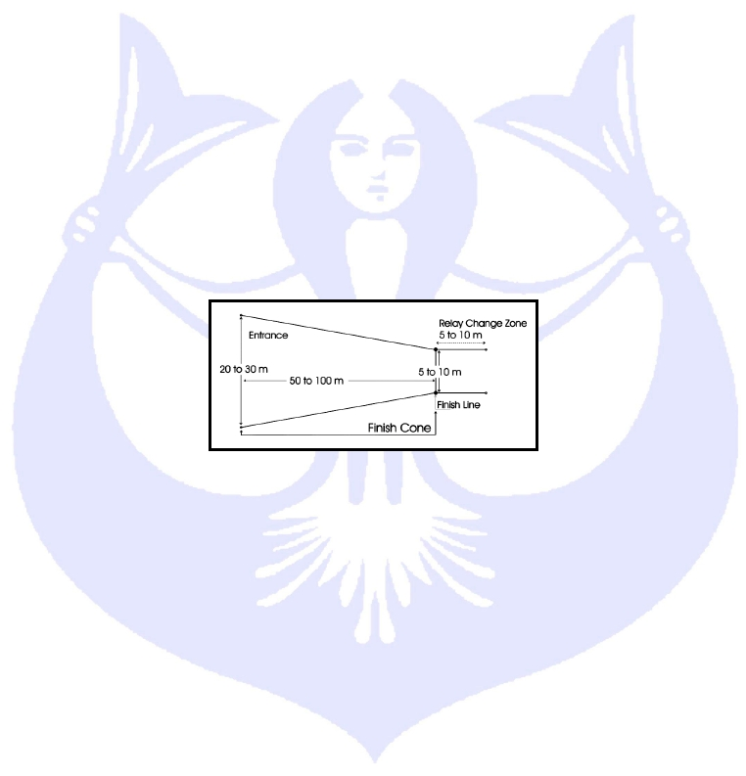

CMAS World Underwater Federation

8.COMPETITION PROCEDURE
8.1. SWIMMING-POOL EVENTS

Finswimming Commission

8.1.1.
Composition of the heats

8.1.1.1.
The starting positions for all events must be decided in the following manner: the

best times in competition of all registered swimmers during the last 12 months, before the
deadline for entry to the competition, must be submitted on the entry form. The swimmers
who do not submit their time must be considered to be the slowest and must be placed at
the end of the list. Drawing lots will place swimmers who have achieved identical times or
swimmers without time. The swimmers must be placed in lanes following the procedures
below.

8.1.1.2.
Races with time classification (direct final): The allocation of the lanes is carried

out in such a way that the fastest swimmer or the fastest team is placed in the centre lane
if there is an odd number of lanes. For swimming pools with even number of lanes the
fastest swimmer gets the lane to the right of the middle lane. The swimmer with the second
fastest time is placed on his left. The other swimmers take alternate places to right and left.
During races of 50 meters and of the nautical mile (1850 meters), the inversion of the
alternation right - left, is possible.

8.1.1.3.
Races with preliminary heats: Swimmers should be placed in the preliminary heats

according to the entry times as follows:
a) The organizer determines the heats according to the number of participants and the
number of pool lanes.
b) If there is only one heat it must be distributed as a final and should take place only
when finals are planned.
c) If there are two heats, the fastest swimmer must be placed in the second heat, the
following in the first, the following in the second, the following in the first etc. …
d) If there are three heats, the fastest swimmer will be placed in the third heat, the next
fastest swimmers in the second, the next fastest in the first. The fourth fastest
swimmers will be placed in the third heat, the fifth fastest in the second heat and the
sixth fastest in the first heat, the seventh fastest in the third heat, etc. …
e) If there are four or more heats, the last three heats of the event will be seeded in
accordance with the above rules (point d.). The heat preceding the last three heats
shall consist of the next fastest swimmers; All participant are divide in group of 24
swimmers and allocated follows the point d) and like the table (see appendix 11.1.2,
etc..

8.1.1.4.
Semi-finals and finals: When the preliminary heats have taken place, the lanes for

the semi-finals and/or the final are determined based on the time obtained in the
preliminary heats following the above point 8.1.1.3.c).

8.1.1.5.
When a swimmer or a team do not wish to participate to a semi-final or a final (A or

B) the swimmer or the team following in the classification are admitted on replacement.
The allocation of lanes for the semi-final or the final is computed again and new starting
lists are published.

8.1.2.
Start (swimming-pool)

8.1.2.1.
Pre-Start

a) Swimmers must put on their caps and goggles in the waiting room, so that they just
have to put on their fins or monofin once on the poolside.
b) Coaches and accompanying persons are not allowed to circulate on the poolside, lest
they be excluded from the area reserved to swimmers.
c) Only the chief judge can allow the coach to intervene in case of a technical problem.
d) If a swimmer arrives later in the waiting room after that the Chief Judge decides that
the swimmers of the heat must go to the starting zone on the pool deck, he won’t be
authorize to access at the pool deck and can’t start.

CMAS Finswimming Rules

Version 2015/01

page 14

CMAS World Underwater Federation

Finswimming Commission

8.1.2.2.

Starting procedure

a) The starting dive must be made from a starting block.
b) At the beginning of each event, the chief judge must signal to the swimmers by “ a
series of brief whistles ”, to take off all clothes except for the bathing-suit, to put on the
fins or monofin. Then, the swimmers have maximum two (2) minutes one and half
minute (1'30") to get ready. A large watch is placed on both sides of the swimming pool
to be easily visible by the swimmers.
c) By “ a long whistle ”, made from the chief judge, the swimmers take position on the
starting blocks. The swimmers and the officials are ready for the start. The chief judge
gives a signal to the starter, with the arm stretched to indicate that the swimmers are
under the control of the starter. Until the start is given the arm must remain stretched.
At the longer whistle of the chief judge the swimmers get on the starting block. If they
wish, the swimmers may already stand on the starting blocks.
d) On the starter command “take your marks” (or “à vos marques” or “a sus marcas”), the
swimmers will immediately take up a starting position and stand still. The position of
the hands is free. When all swimmers are stationary, the starter will give the starting
signal.
e) When one or more swimmers dive or move before the starting signal will be
disqualified. If the starting signal has been given before announcing any
disqualification, the race continues and the swimmers who have anticipated are
disqualified at the end.

f)
If the disqualification is announced before the starting signal then the signal must not

be given, the swimmers who remain in the race are recalled and the starter gives again
the starting signal (point c and d).
g) The decisions of the starter or of the chief judge about false starts are definitive.

8.1.3.
General rules (swimming-pool)

8.1.3.1.
For distances above 400 meters, the judges must inform the swimmers of the last

length (100 meters) left by immersing a board of bright colour of minimum dimensions 20
centimetres X 30 centimetres. If it is impossible, for technical reasons, to make this signal
at the starting end of the pool, this must be done by the turn-judges at the turn end, when
150 meters are left in the race.

8.1.3.2.
Swimmers who drop out of the competition must leave the water following the

instructions of the judges. They must do the same when the race is over.

8.1.3.3.
Any swimmer crossing his lane or who hinders another swimmer by any other

means will be disqualified. If this behaviour is intentional, the chief judge must report the
matter to the CMAS Technical Delegate and to the national federation of the swimmer.

8.1.3.4.
In all races, swimmers must at each turn, make physical contact with a part of the

body or the equipment with the extreme end of the pool. (Not the tank, 2.2.3.6)

8.1.3.5.
At the relay races, a team is disqualified if the feet or the fins of the next starting

swimmer have already left the starting block before the arriving swimmer has touched the
wall of the pool; the team isn’t disqualified if the starting swimmer notices his mistake and
returns to the wall and starts again. It’s not necessary to climb on to the starting block.

8.1.3.6.
For relay races the names of the swimmers and their starting order must appear in a

list submitted to the results office before the start of the session. Any change in the fixed
starting order leads to disqualification.

8.1.3.7.
Having completed his part of the relay, the swimmer must remain in his lane (at

about 1 meter distance to the electronic touch pad) until the judges instruct him to leave
the pool.

8.1.3.8.
It is forbidden for the swimmers, who have finished their relay, to enter the water

before the end of the race, i.e. before the arrival of the last team.

8.1.3.9.
It is forbidden to exit over the electronic touch pads. If a swimmer does go out in this

way, he will be disqualified.
8.1.3.10. The swimmer who loses part of his equipment, fin(s), snorkel, breathing apparatus
during the race (SF, AP, IM, and BF) is disqualified on arrival.

CMAS Finswimming Rules

Version 2015/01

page 15
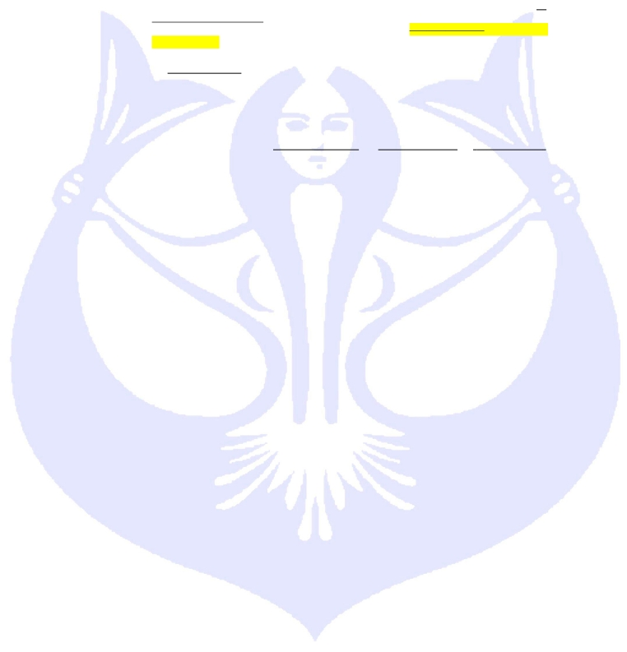

CMAS World Underwater Federation

Finswimming Commission

8.1.4.

Disqualification and withdrawal

8.1.4.1.
In all competitions, a swimmer or a team not wishing to take part in the final or semi-

final or swim off for which s/he had qualified, must announce his/her withdrawal within 30
minutes following the announcement of the qualifying finalists. The swimmer will be
replaced by the swimmer or team having qualified one place immediately behind him/her.

8.1.4.2.
If a swimmer, who participated in a final, is disqualified, his position must be given to

the swimmer who finished immediately after him. All swimmers classified following him in
the final must be advanced by one place. If the disqualification occurs after the awards
ceremony, the awards (medals and diplomas etc.) must be given back and handed over to
the appropriate swimmers applying the above criteria.

8.1.4.3.
Except for the cases covered by the point 8.1.4.1. and except the withdrawal

communicated during the technical meeting, for every non participation in a heat of an
event during a CMAS Championship, the federation of the absent swimmer will be liable
for a fine of € 100.

8.1.4.4.
Except for the cases covered by the point 8.1.4.1., for every non participation in a

semi-final or final of an event during a CMAS Championship, the federation of the absent
swimmer will be liable for a fine of € 250.

8.1.5.
Swim-off

8.1.5.1.
If in the same event several swimmers touch the wall simultaneously they are

awarded the same rank in the official record. For identical times at a 1/100 of a second
achieved in different heats this rule is equally valid.

8.1.5.2.
If a decision must be taken regarding the qualification for a semi-final or a final, it’s

the best result of a classification race that will be decisive.

8.1.5.3.
Such swim-off can take place not less than one hour after the swimmers involved

have completed their heat.

8.1.5.4.
When swimmers have identical times, but the order has been decided by the

finishing judge or by the chief judge, the decision on this order determines also the
qualification to the finals.
8.1.5.5. The swimmer who is not participating in the swim-off for the final A is automatically
th
th
there is a disqualification of a swimmer in final B.

8.1.5.6.
If a swimmer is disqualified during or after an event, the disqualification must be

recorded in the official protocol but no time or place shall be recorded.
th th

8.1.5.8.
If there is a disqualification in a relay, the intermediate times up until the

disqualification must be recorded in the official protocol.
8.2. OPEN WATER EVENTS

8.2.1.
All open water events will start in water with a sufficient depth that allows swimmers to

swim as soon as the starting signal is given.

8.2.2.
Starting Procedure

8.2.2.1.
When the starting order is drawn by lots, the drawing must be made in public by the

board of judges.

8.2.2.2.
8.2.2.3.
Swimmers must be placed on a starting line perpendicular to the swimming direction.
The chief judge announces the start “15 minutes ” before it, then again “5 minutes”

before it. He then signals that the competition is under the starter's orders.

8.2.2.4.
8.2.2.5.
The starter must be clearly visible to all the swimmers.
The starter announces the start “one minute” before, then again “30 seconds”

before. In the same time, the thirty (30) seconds are signalled by an audible and visual
signal (rising of the flag).

8.2.2.6.
The counting of the last ten seconds is strictly forbidden. The starter gives the

starting signal directly.

8.2.2.7.
The starting signal must be both audible and visible (lowering the flag).

8.2.3.
During Finswimming competitions in open water, security and escort boats must be kept

outside the area reserved to the competition, so as not to obstruct swimmers.

CMAS Finswimming Rules

Version 2015/01

page 16

placed on the 9 place (given 8 lanes) and participates in final B. In case of a swim-off for
final B, the absent swimmer is automatically classified 17 . This place is kept even when
8.1.5.7.
In case of a final A the swimmer is classified 8 and 16 for a final B.

CMAS World Underwater Federation

Finswimming Commission

8.2.4.

For the relay races, the names of the swimmers and their starting order must appear in a

list submitted to the Chief Judge by the team leader in the same time he receive numbers of
the swimmers.
9.BOARD OF JUDGES AND COMPETITION MANAGEMENTS
9.1. CMAS TECHNICAL DELEGATE

9.1.1.
The CMAS Technical Delegate, appointed by CMAS BOD under proposal of the

Finswimming Commission, has the full control and authority over all the championship. The
CMAS Technical Delegate may intervene in the competition at any stage to ensure that the
CMAS regulations are observed.

9.1.2.

9.1.3.
Rights and duties
a) He has the duty to make an inspection of all the installations necessary for the
competition.
b) He has the duty to check the participants’ files concerning the sport license and
passport for the identification
c) He has the duty to enforce CMAS regulations and decisions, and resolve all matters
about the actual organization of the competition when the rules do not provide another
solution, also concerning the board of judges.
d) He has the right to cancel or suspend the competitions in bad weather conditions and if
the site and installations of the competitions does not comply with the requirements of
the CMAS rules.
Protest

a) The CMAS Technical Delegate must examine the protests and take decisions on them
within one hour after the submission of the appeal. Also related to the competition in
progress.
b) Decisions taken by the CMAS Technical Delegate are final.
c) The decision of the CMAS Technical Delegate must be communicated in writing to the
plaintiff immediately after the officially decision.
9.2. THE BOARD OF JUDGES
It is set up by the organizers. It is entirely responsible for the preparation and the staging of
the event. Its composition depends on the nature of the competition. In the pool events the
panel sets up as follows:














one chief judge
one chief secretary
one starter
one pre-start judge
one chief time-keeper
one time-keepers per one/two lane one (if electronic time keeping) to three time-
keepers per lane
two finish judges
two style judges
two to eight turning judges
one speaker
one master of ceremonies
one doctor

9.2.1.
The Chief Judge
He has full control and authority upon all officials. He must approve their assignment and
give them the instruction about the particular rules of the championship. He is responsible
for technical conditions of the competition and for ensuring compliance with the prevailing
safety regulations. His rights and duties are the following:

a)
b)
He has the duty to check the entry forms and the starting order
He is responsible for appointing the finalists, semi-finalists and for the publication of
the results

CMAS Finswimming Rules

Version 2015/01

page 17
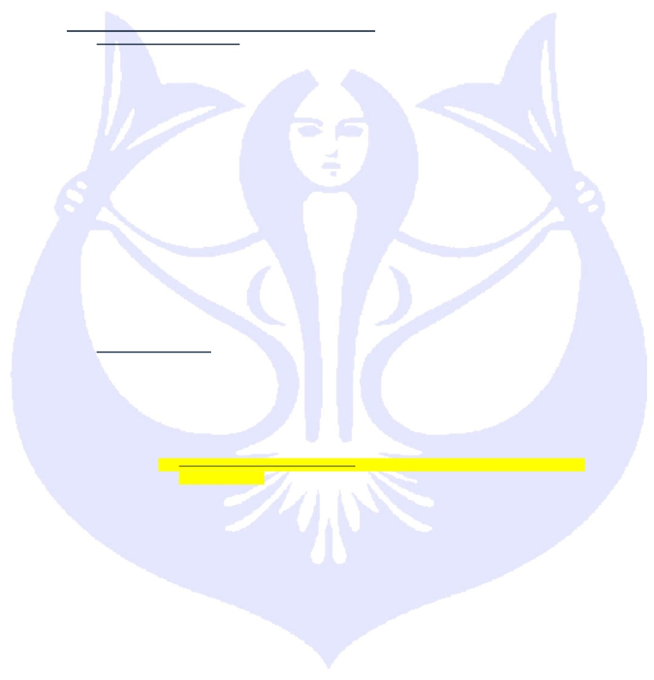

CMAS World Underwater Federation

Finswimming Commission

c) He has the duty to enforce CMAS regulations and decisions, and resolve all matters
about the actual organization of the competition when the rules do not provide another
solution.

d)

e)

f)

g)
He decides the place of all judges for the perfect staging of the event. He may at any
time replace a judge if the original judge does not properly fulfil or is incapable of
fulfilling his tasks, or is absent. He can nominate additional judges if he values it
necessary
The chief judge authorizes the starter to proceed with the start. Beforehand he must
make sure that all members of the board of judges are ready
Independently from the starter he can decide whether there has been a false start or
not
He must make sure that the equipment and apparatus necessary for the staging of the

event is available in good time
h) During competitions in open water, he is responsible for accurate positioning of the
course according to the plans published in the bylaws for these competitions

i)
j)
He decide the deployment of boats, the security and radio communication
The organizer must put a sufficient number of assistants at his disposal so that he can

fulfil his tasks without any difficulties.
k) The Chief Judge shall disqualify any swimmer for any violation of the rules that he
personally observes. The Chief Judge may also disqualify any swimmer for any
violation reported to him by other authorised officials. All disqualifications are subject to
the decision of the Chief Judge.

9.2.2.
The Chief secretary

a)

b)
c)
d)
e)
f)
He prepares all administrative material and the documentation needed for the
competitions
He appoints the deputy secretaries and directs their work
He must control the withdrawal after the heats or finals
He is responsible for the handing of the time-keeper’s forms to the poolside secretary
He supervises the work of drafting minutes of the technical commission meetings.
He prepares the final protocol of the competitions after they have ended

g) With the authorization of the chief judge he gives information on the competitions to
the press if there is no special press office.
h) He is responsible for the verification of the results of the competition given by the
computer or the times and classification given by the chief judge.

i)
j)

k)
l)
He verifies the results and ratifies new records and inserts them into the protocol
He must make sure that the decisions of the finishing judge and of the chief judge are
inscribed in the official protocol
He co-ordinates the electronic time-keeping which is operated by qualified technicians
He controls the official protocol, signs it and passes it on the get the signature by the

chief judge
m) He transmits to the speaker the results concerning finals and awards ceremonies
n) The chief of the result office must give the official protocol and the results to the
secretary only after approval by the chief judge.

9.2.3.
The starter

a)

b)

c)

d)
He has complete authority over the swimmers from the moment the chief judge has
handed over the control of the race to him and until the start of the race
The starter must indicate to the chief judge any swimmer who delays the start, refuses
to respect an order or does not behave correctly during the starting procedure. Only
the chief judge can disqualify this swimmer for unsporting behaviours. This kind of
disqualification cannot be considered as a false start
He has the right to decide whether the start is correct or not, provided that the chief
judge is of the same opinion.
The starter can anticipate the start when he judges that a swimmer exaggeratedly
delays taking up his starting position

CMAS Finswimming Rules

Version 2015/01

page 18

CMAS World Underwater Federation

Finswimming Commission

e)

f)

The position of the starter when he gives the starting signal must be on the side of the
pool about five meters from the extremity walls. The time-keepers and all participants
should be able to hear him clearly
He coordinates the evacuation of the pool at the end of each event.

9.2.4.
The pre-start judge

a)
b)

c)
He must call the participants in due time for each of the events
He must signal to the chief judge all violations noticed, that are related to the
announcement and absence of the called swimmer
He must check if the equipment complies with the rules and if the participants are

ready to start
d) . He leads the swimmers to the starting point. Assistants may perform this task.

9.2.5.
The chief of time-keepers

a)

b)

c)

d)
e)
He assigns the lanes to the time-keepers. There must be one (1) to three (3) time-
keepers per lane. If the automatic timing is not employed, there must be two (2)
additional time-keepers. They are responsible for substituting the time-keepers whose
stopwatch failed during the event, or who, for any reason, cannot measure the time.
Together with the time-keepers the chief time-keeper checks and approves the
reliability of the stopwatches in use.
He receives, from all time-keepers, the timing cards, checks the entries and
stopwatches if necessary.
He records and checks the official time of the timing card for each swimmer.
He supervises the activity of each time-keeper and takes control times himself. He
passes on the times recorded for each swimmer to the pool-side secretary.

9.2.6.
The time-keepers

a)

b)

c)

d)

e)
They record the times of the swimmers for whom they are responsible. They use stop
watches approved by the chief time-keeper or chief judge
At the signal for the start the time-keepers start their stopwatches and stop them when
the swimmer has touched the finishing pad. Immediately after the event they must
write the time displayed by their stopwatches on the timing card which they hand over
to the chief time-keeper. At the same time they show their stopwatches for control
They must not reset their stopwatches to zero before the chief time-keeper or chief
judge tells them “stopwatches to zero”
They are responsible for the recording of the intermediate times in races of more than
100 meters’ distance
Their task is also to check that the turns and the finish are in accordance with the
regulation.

9.2.7.
The finish judges

a)
b)

c)

d)
e)
f)
There are two or more finishing judges
They are positioned on each side of the pool directly over the finishing line from where
they can have at all times a good view of the swimming lane and the finishing line
They establish the classification of the swimmers and they hand it over directly to the
results office
They supervise the relay procedure
They are not allowed to be time-keepers in the same event
The finishing judges' decisions take precedence over the classification given by the
manual stopwatches only if there are fewer than three digital stopwatches per lane.
They cannot be appealed if they are unanimous. If the arrival judges' decisions are not
unanimous, it is the chief judge who decides on the placing. The protocol must then
bear the mention 'CJD' (chief judge decision) next to the time.

9.2.8.
The swimming-style judges

a)

b)
c)
There are two swimming-style judges (swimming pool) and more for open Water
competition
They are positioned one for each side of the pool
They must check that the rules for swimming style are observed

CMAS Finswimming Rules

Version 2015/01

page 19

CMAS World Underwater Federation

Finswimming Commission

d)

e)
f)

They must check if the swimmers respect the 15 m zone after the start and after each
turn beyond which immersion is prohibited
Assistants may perform this control
They must immediately inform the chief judge of all violations of rules on a signed
card. This card must contain the type of event, heat number and lane number.

9.2.9.
The turning judges

a)
b)
c)

d)
They are nominated for each lane by the chief judge
They must check whether the swimmer has carried out his turn according to the rules
In individual events of 800 and 1500 meters, each turning judge at the extremity of the
pool may be told to inform the swimmers on the last 150 meters
They must report all violations on their cards, sign it, and specifying the event, the

number of the lane, and the specific infraction. These cards will be immediately
handed to the chief judge.
9.2.10. The speaker

a)

b)
c)

d)
He has the task to call the swimmers and teams and to introduce them to the
spectators
He must announce the results if there is no spectator score board
He must give information about the competition in order to make the event interesting
and he must also announce new records
He is responsible for the announcement of all disqualifications.

9.2.11. The master of ceremonies

a)
b)

c)
The master of ceremonies prepares beforehand the medals, flowers and other awards
He is in charge of the arrangements of the awards podium, the national anthems, the
ceremonies and the flags and organizes the ceremony for the medals presentation
He calls and gathers the swimmers, the officials and the carriers of the medals in the

appropriate order for the protocol ceremony.
9.2.12. The doctor
a) He’s a member of the board of judges.
b) He ensures the supervision of the medical control. The presence of at least one doctor
at all finswimming events is compulsory
c) He’s responsible for all sanitary, hygienic and medical questions (helps in case of
danger, assists with the preparation of the time plans, menus, the sanitary control of
accommodations, control of the medical health certificates, doping-tests, etc.)
d) Before each competition he must check the functioning of the necessary medical
equipment.
e) A medical control can be carried out at any time during the competition.
9.3. JUDGES’ DECISION MAKING:
Judges shall make their decision autonomously and independently of each other unless
otherwise provided in the CMAS Finswimming Rules.
9.4. COMPETITION MANAGEMENTS

9.4.1.
Competition Director

a) Named from the Organizing Committee.
b) He represents the competition organizing committee.
c) He’s responsible of the organizing and logistic matter during the competition.
d) He strictly work with the Chief Judge and the CMAS Technical Delegate
10.FINSWIMMING RECORDS
10.1. DISCIPLINES AND DISTANCES
All the finswimming records concern only the following disciplines and distances for
both sexes in the juniors and seniors categories

CMAS Finswimming Rules

Version 2015/01

page 20

CMAS World Underwater Federation

10.1.1. Surface Finswimming (SF)

Finswimming Commission







10.1.2. Relays


50 m
100 m
200 m
400 m
800 m
1500 m

4 x 100 m
4 x 200 m

10.1.3. Apnoea finswimming (AP)


50 m

10.1.4. Immersion Finswimming (IM)




100 m
400 m
800 m

10.1.5. Bi-Fins (BF)




50 m
100 m
200 m

10.2. PARTICULAR RULES FOR RELAYS AND INTERMEDIATE DISTANCES
10.2.1. Relay
The members of a relay team must be of the same nationality.
If the first swimmer of a relay breaks a World or Continental Record of the 100 m or
200 m Surface this performance will be managed as a new record.
Should the first swimmer in a relay team complete his distance in record time in
accordance with the provisions of this subsection, his performance shall not be
nullified by any subsequent disqualification of his relay team for violations occurring
after his distance has been completed
10.2.2. Intermediate distances
If a swimmer in an individual event breaks a World or Continental Record at an
intermediate distance this performance will be managed as a new record.
10.3. KIND OF CMAS RECORDS

➢
➢
➢
➢
➢
World records
Continental records
World championships records
Continental championships records
World Games records

10.4. HOMOLOGATION OF RECORDS
Records are homologated by and only by CMAS under the following conditions.
10.4.1. According Point 4.2 of CMAS Procedures for Homologation of the records.
10.4.2. The length of the pool must be 50 meters, ratified and confirmed by the national
federation.
10.4.3. Times must be reported by Electronic Automatic Officiating Equipment. The print of the
Electronic time has to be joined.
10.4.4. Applications for Records must be made on the CMAS official forms (see the appendix) by
the responsible authority of the organizing or management committee of the competition and
must be signed by the Chief Judge, certifying that all regulations have been observed.
10.4.5. Ex aequo
Times which are equal to 1/100 of the second will be ratified as equal records and the
swimmers achieving these equal times will be called “Joint Holders”. In case of a tie at the
first place in a record-setting race (qualification heat) each swimmer who tied shall be
considered a winner.

CMAS Finswimming Rules

Version 2015/01

page 21

CMAS World Underwater Federation

Finswimming Commission

10.5. OUT OF CHAMPIONSHIPS RECORDS
10.5.1. Individual race against time
10.5.2. In this case, the tentative has to be held in public, announced publicly by advertisement at
least three days before the attempt is to be made
10.5.3. A request for ratification of a Record must be sent as provisional procedure by fax or e-
mail to CMAS headquarters within 7 days following the performance
10.5.4. On receipt of the official application, and upon satisfaction that the information contained
in the application is accurate. The General Secretary of CMAS shall inform President of
Finswimming Commission and declare the new Record, see that such information is
published, and see that certificates are provided to those persons whose applications have
been accepted.
10.5.5. If the ratification of a Record is accepted by CMAS, a diploma signed by the President of
CMAS and by the President of the Finswimming Commission, will be sent to the swimmer.
10.6. WORLD CHAMPIONSHIPS RECORDS / CONTINENTAL CHAMPIONSHIPS RECORDS / WORLD GAMES
RECORDS
If during these events, the best time registered in the past events is broken, this time will be
registered as a new record of the event as longer as the requisites written in these rules are
encountered.
10.7. NATIONAL RECORDS.
The national records are recognised by CMAS as longer as they are officially communicated to
CMAS by the federation and as longer as the time of the record is not less than the time of the
CMAS World and/or Continental record.

CMAS Finswimming Rules

Version 2015/01

page 22
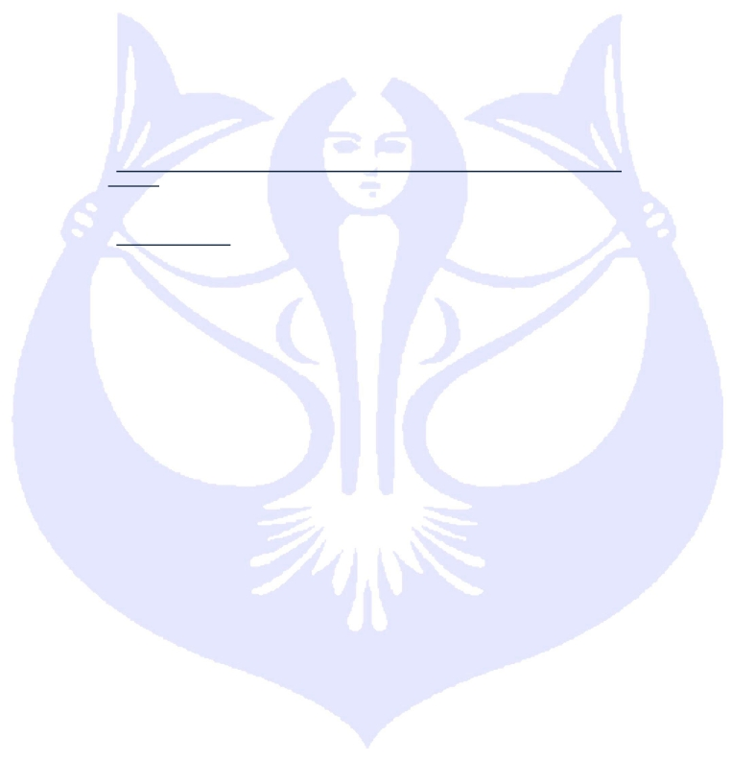

CMAS World Underwater Federation

Finswimming Commission

11.APPENDIX CMAS FINSWIMMING RULES
11.1. STARTING SETTING
11.1.1. Direct Final (8.1.1.2.): Allocation of lanes for in a swimming pool with 8 lanes. All
participant are divide in group of 8 swimmers and allocated like the follow table (1=fastest entry
time, 2= second entry time, 3= third entry time … and so on).

11.1.2. Qualification Heats (8.1.1.3.): Allocation of lanes for in a swimming pool with 8 lanes for
60 participants. All participant are divide in group of 24 swimmers and allocated like the follow
table (1= fastest entry time, 2= second entry time, 3= third entry time … and so on).

11.2. MODEL OF TEMPLE FOR MEASURING THE MONOFIN

11.3. ALL CMAS OFFICIAL FORMS ARE AVAILABLE IN THE “PROCEDURES AND OBLIGATIONS FOR THE
ORGANIZATION OF CMAS CHAMPIONSHIPS” DOCUMENTS.

11.4. INTERNET:
http://www.cmas.org/comspo/nap/

11.5. ANTIDOPING:
http://www.cmas.org/sport/anti-doping, cmas.dopingfree@sportaccord.com
Anti-doping section on the CMAS website and a dedicated e-mail address for all CMAS anti-doping
matters, information and administration, managed by the DFSU.

11.6. BI FINS CERTIFIED
Concerning point 2.3.2

11.7. SWIMSUITS
Concerning point 2.3.3.5.

CMAS Finswimming Rules

Version 2015/01

page 23
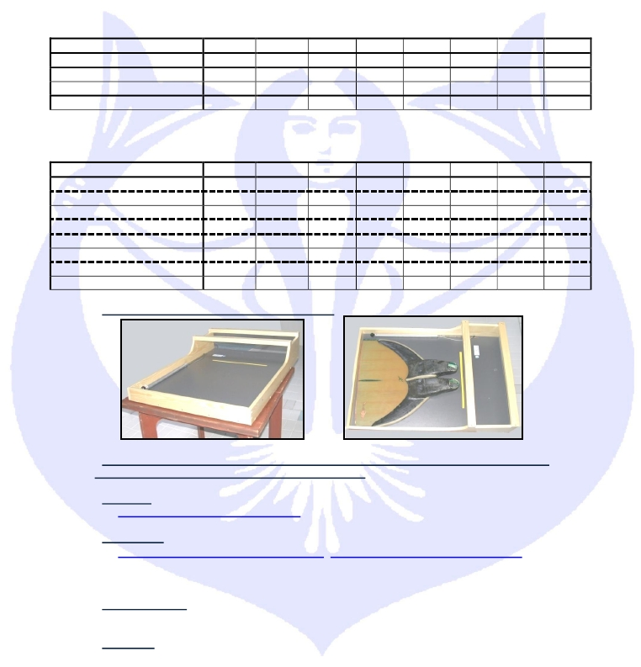

Lane | 1 | 2 | 3 | 4 | 5 | 6 | 7 | 8
Last but seven heats  Last but six heats | …  55 | …  53 | 59  51 | 57  49 | 58  50 | 60  52 | …  54 | …  56
Last but five heats  Last but four heats  Last but three heats | 45  44  43 | 39  38  37 | 33  32  31 | 27  26  25 | 30  29  28 | 36  35  34 | 42  41  40 | 48  47  46
Last but two heats  Last but one heat | 21  20 | 15  14 | 9  8 | 3  2 | 6  5 | 12  11 | 18  17 | 24  23
Last heat | 19 | 13 | 7 | 1 | 4 | 10 | 16 | 22
Lane | 1 | 2 | 3 | 4 | 5 | 6 | 7 | 8
…and so on… | … | … | 27 | 25 | 26 | 28 | … | …
Last but two heat | 23 | 21 | 19 | 17 | 18 | 20 | 22 | 24
Last but one heat | 15 | 13 | 11 | 9 | 10 | 12 | 14 | 16
Last heat | 7 | 5 | 3 | 1 | 2 | 4 | 6 | 8

